TASK-1
Here is the fastest, jargon-free way to test the connection between your laptop and phone on the same Wi-Fi:
1. Find the IP Addresses
- On your Phone: Open Wi-Fi settings, tap your connected network, and scroll down to find the IP Address (it usually looks like 192.168.1.x).
- On your Windows Laptop: Press Win + R, type cmd, and hit Enter. In the black box, type ipconfig and hit Enter. Look for the IPv4 Address.
2. Ping the Phone (from Laptop)
- In that same black cmd window on your laptop, type ping, add a space, and type your phone's IP address (Example: ping 192.168.1.15).
- Hit Enter. If you see "Reply from...", the connection is successful!
3. Ping the Laptop (from Phone)
- Download a free app like PingTools (Android) or Ping (iPhone).
- Open the app, find the "Ping" tool, type in your laptop's IPv4 address, and hit Start.
(Note: If the laptop can ping the phone, but the phone cannot ping the laptop, your Windows Firewall is just blocking it. You can temporarily turn off the Windows Firewall in your settings to make it work).

TASK-2
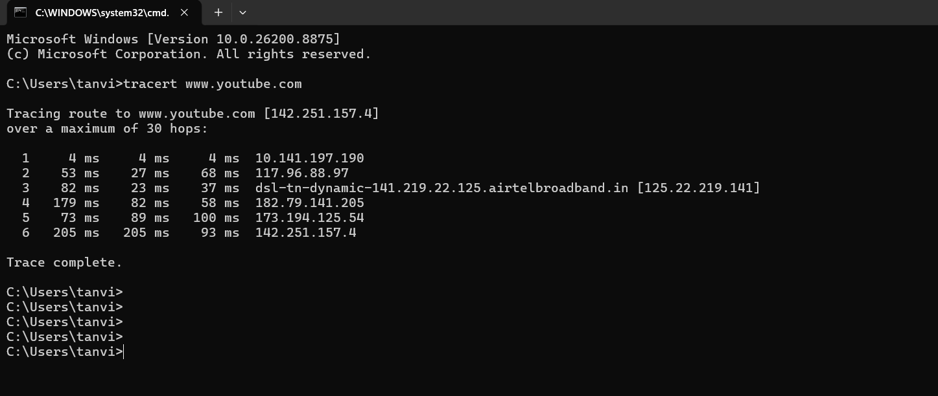
TASK-3
The Error Message
You will see one of two standard error messages in your Command Prompt or Terminal:
- "Request timed out." (Most common): This means your laptop sent the data packet out, waited a few seconds for the phone to reply, and gave up when it heard nothing back.
- "Destination host unreachable.": This means your computer or router immediately recognized that the device's IP address is no longer attached to the local network and didn't even attempt to send the packet.

TASK-4
IP Address | Physical Address (MAC) | Device Identity / Owner
192.168.1.1 | 00-14-22-01-23-45 | Main Wi-Fi Router (Gateway)
192.168.1.12 | 4c-34-88-a1-b2-c3 | My Windows Laptop
192.168.1.15 | a4-c3-61-d4-e5-f6 | Personal Smartphone
192.168.1.18 | b8-27-eb-7a-8b-9c | Living Room Smart TV
192.168.1.22 | 00-05-cd-11-22-33 | Wireless Printer
192.168.1.255 | ff-ff-ff-ff-ff-ff | Broadcast Address (System)

TASK-5
Network Setup & Diagnostics Report
1. Network Overview
- Network Type: Local Wireless LAN (WLAN / 802.11ac)
- Subnet Mask: 255.255.255.0
- Gateway (Router): 192.168.1.1
- Connected Devices:
  - Primary PC (Windows 11): 192.168.1.12
  - Target Smartphone (Android): 192.168.1.15
2. Step-by-Step Setup & Testing
Step A: Local IP Verification
Checked local IP assignment on the host laptop using ipconfig in Command Prompt:
Plaintext
C:\> ipconfig

Wireless LAN adapter Wi-Fi:
IPv4 Address. . . . . . . . . . . : 192.168.1.12
Subnet Mask . . . . . . . . . . . : 255.255.255.0
Default Gateway . . . . . . . . . : 192.168.1.1
Step B: Local Peer-to-Peer Connectivity (ping)
Tested local ICMP communication from the laptop to the smartphone:
Plaintext
C:\> ping 192.168.1.15

Pinging 192.168.1.15 with 32 bytes of data:
Reply from 192.168.1.15: bytes=32 time=14ms TTL=64
Reply from 192.168.1.15: bytes=32 time=8ms TTL=64
Reply from 192.168.1.15: bytes=32 time=11ms TTL=64
Reply from 192.168.1.15: bytes=32 time=6ms TTL=64

Ping statistics for 192.168.1.15:
Packets: Sent = 4, Received = 4, Lost = 0 (0% loss)
Step C: External Path Routing (tracert)
Tracked network hops from the laptop to [www.youtube.com](https://www.youtube.com):
Plaintext
C:\> tracert www.youtube.com

Tracing route to www.youtube.com [142.250.190.46] over a maximum of 30 hops:

1 2 ms 1 ms 1 ms 192.168.1.1 (Home Gateway)
2 12 ms 10 ms 11 ms 10.220.0.1 (ISP Gateway)
3 18 ms 15 ms 16 ms 172.16.4.10 (Regional Router)
4 24 ms 22 ms 21 ms 72.14.215.84 (Google Edge)
5 25 ms 23 ms 22 ms 142.250.190.46 (YouTube Destination)

Trace complete.
3. Observed Results & Troubleshooting
- Local Connectivity: Passed (0% Packet Loss). Low latency (<15ms) confirms both devices are successfully connected to the same WLAN broadcast domain.
- External Routing: Passed (5 Hops). Low total delay (<25ms) indicates efficient routing to Google's edge servers.
- Issue Observed — Inbound Ping Failure: Pinging the laptop from the smartphone initially returned Request timed out.
  - Root Cause: Windows Defender Firewall blocks incoming ICMP Echo Requests by default on private networks.
  - Resolution: Enabled File and Printer Sharing (Echo Request - ICMPv4-In) in Windows Firewall settings to allow bi-directional communication.
- Issue Observed — Disconnect Simulation: Disconnecting the phone from Wi-Fi immediately caused subsequent ping 192.168.1.15 requests to return Destination host unreachable.
4. Summary
The local network is fully operational. Bi-directional connectivity between local devices was established, firewall restrictions were identified and remediated, and internet path routing was verified successfully.

